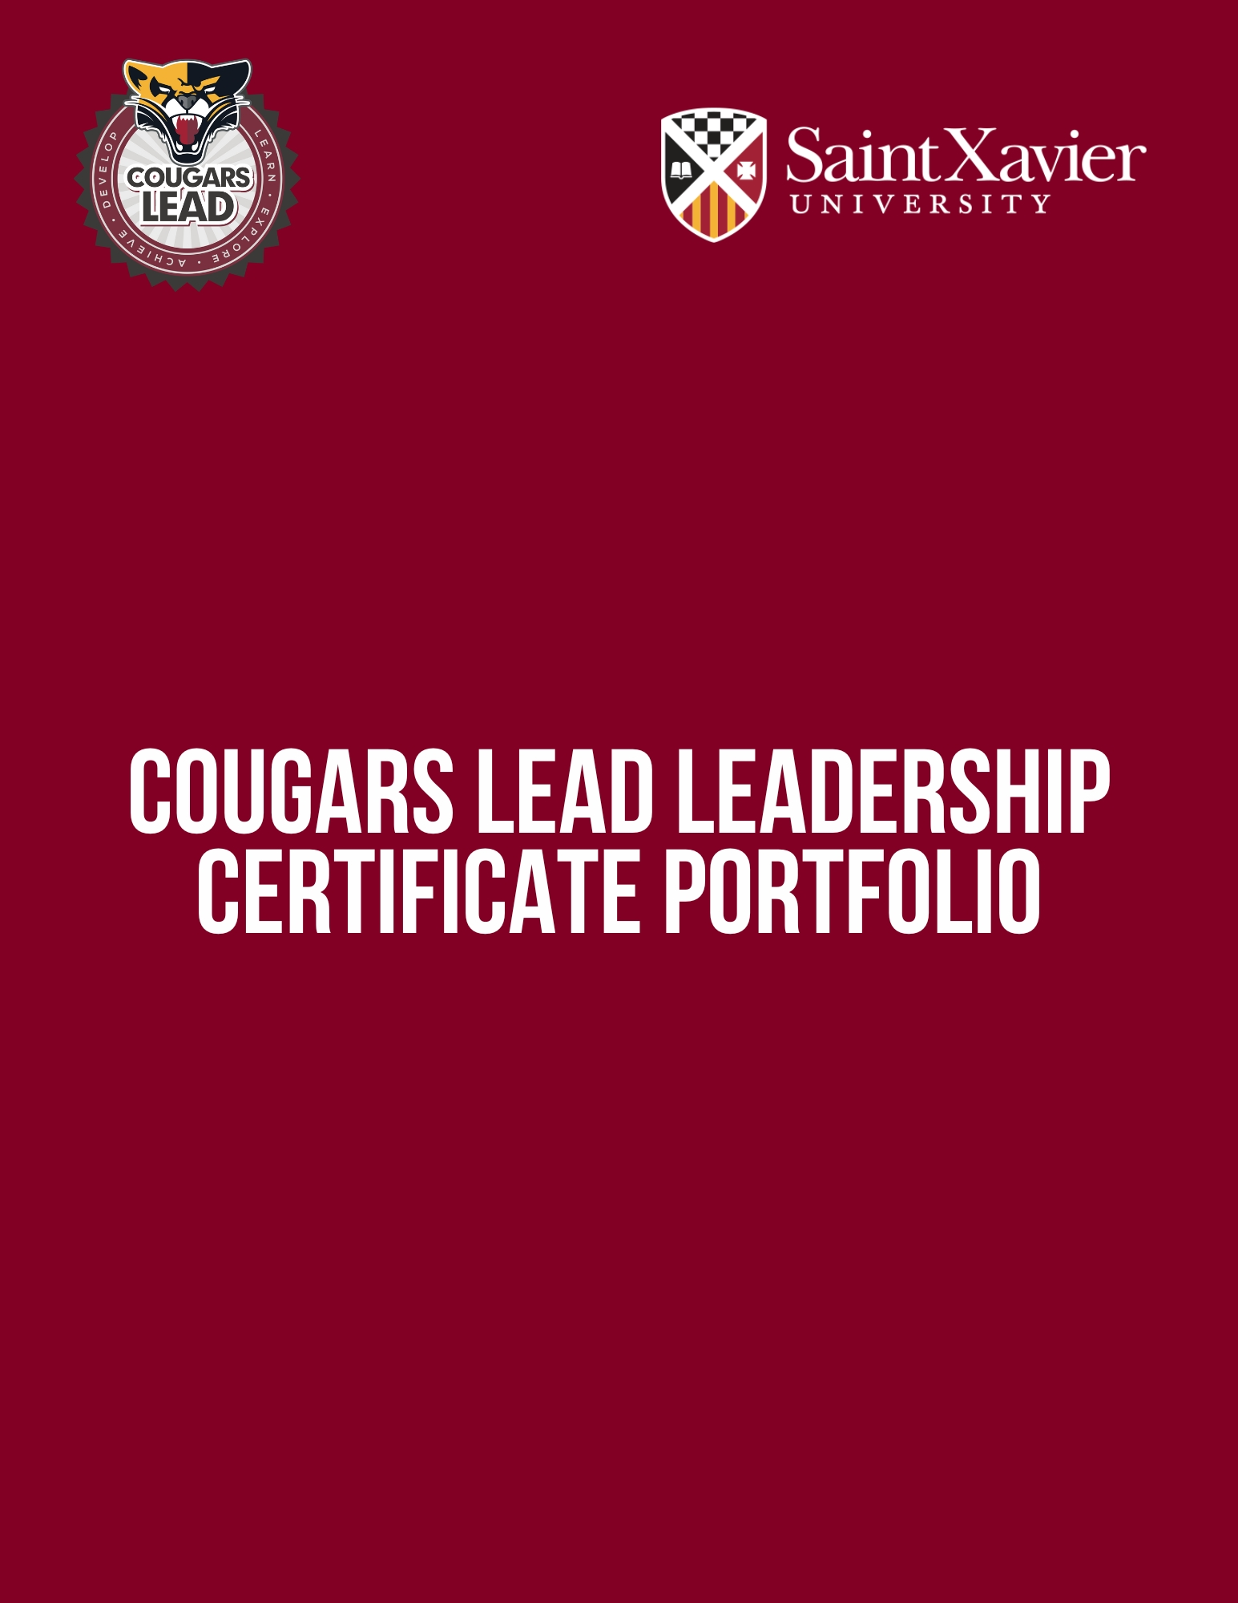
[Insert First Name] [Insert Last Name]
Date: [Insert Date]
Cougars LEAD Leadership Portfolio Entry Sample

Below you will find an example for a submission for one of the individual leadership experiences. More information regarding current guidelines for the Portfolio can be found on the SXU Cougars LEAD website.

Transformational Leadership Experience 1

- Name of the Experience: Diversity, Equity, and Inclusion in the Workplace

- Description of the Experience: This event focused on the importance of diversity, equity, and inclusion in the workplace which included understanding why creating an inclusive environment is crucial for fostering a positive and productive workplace culture. Additionally, the event focused on best practices for promoting diversity and inclusivity, how DEI directly influences employee well-being, and explored practical examples of how companies have successfully implemented DEI initiatives.

- Experience Date: 7/20/2023

- Proof of Completion: (selfie, event photo, or another means of verifying attendance, e.g., event sign in): Below is an image from the event which includes Sam Sample presenting on the topic of integrating DEIB into workplace culture.

How did this experience enhance your leadership identity, leadership style for this category, or skillset?: Participating in this event was a significant milestone in enhancing my leadership identity and skillset, specifically in the realm of diversity, equity, and inclusion (DEI). The event illuminated the critical role of fostering an inclusive workplace to cultivate a positive and productive culture. By delving into the importance of diversity, I recognized that a diverse workforce brings together varied perspectives and experiences, fostering innovation and creativity within teams. I now grasp the significance of actively promoting inclusivity to ensure that all team members feel valued and empowered to contribute fully. This experience also prompted a shift in my leadership style. I now prioritize adaptability, empathy, and open communication to understand and address the unique needs and challenges faced by each team member. By implementing best practices discussed at the event, such as mentorship programs and unbiased recruitment strategies, I aim to create an environment that supports individual growth and development. Overall, this event has equipped me with the knowledge and tools to lead more effectively and create a workplace where diversity, equity, and inclusion are celebrated, fostering a thriving and harmonious atmosphere for all employees.
Cougars LEAD Leadership Portfolio

Table of Contents
Core Experiences

Transformational Leadership………………………………………………………………………………………………………………………………….……… Pg. X
Situational Leadership…………………………………………………………………………………………………………………………………………………… Pg. X
Authentic Leadership…………………………………………………………………………………………………………………………………………………….. Pg. X
Experiential Leadership…………………………………………………………………………………………………………………………………………………. Pg. X
Servant Leadership………………………………………………………………………………………………………………………………………………………… Pg. X

Additional Experiential Requirements
Synergy Leadership Summit Reflection…………………………………………………………………………………………………………………………. Pg. X
Leadership Philosophy Statement…………………………………………………………………………………………………………………………………. Pg. X
Cougars LEAD Final Reflection……………………………………………………………………………………………………………………………………….. Pg. X
Cougars LEAD Leadership Portfolio

Transformational Leadership (4 Experiences)

What is a transformational leader?
Transformational leaders value diversity and recognize the importance of creating a positive and inclusive work environment that values and celebrates differences. They encourage and support the contributions of all team members, regardless of their backgrounds or identities, and they work to create a culture of respect, open communication, and collaboration. Transformational leaders also recognize the value of diversity in promoting innovation and creativity, and they actively seek out and incorporate diverse perspectives and ideas into their decision-making processes. Institutional Core Value(s) related to this leadership style category include Diversity, Respect, Compassion, and Hospitality.

What experiences count toward this category?
Students must complete 4 individual experiences of their choosing which include planning or attending diversity, equity, and inclusion events, attending cultural celebrations, participating in organizations tied to diversity, equity, inclusion, or identity, and or demonstrating activism or advocacy to name a few.

Transformational Leadership Experience 1

- Name of the Experience:
- Description of the Experience:
- Experience Date:
- Proof of Completion: (selfie, event photo, or another means of verifying attendance, e.g., event sign in)
- How did this experience enhance your leadership identity, leadership style for this category, or skillset?

Transformational Leadership Experience 2

- Name of the Experience:
- Description of the Experience:
- Experience Date:
- Proof of Completion: (selfie, event photo, or another means of verifying attendance, e.g., event sign in)
- How did this experience enhance your leadership identity, leadership style for this category, or skillset?

Transformational Leadership Experience 3

- Name of the Experience:
- Description of the Experience:
- Experience Date:
- Proof of Completion: (selfie, event photo, or another means of verifying attendance, e.g., event sign in)
- How did this experience enhance your leadership identity, leadership style for this category, or skillset?

Transformational Leadership Experience 4

- Name of the Experience:
- Description of the Experience:
- Experience Date:
- Proof of Completion: (selfie, event photo, or another means of verifying attendance, e.g., event sign in)
- How did this experience enhance your leadership identity, leadership style for this category, or skillset?

Cougars LEAD Leadership Portfolio

Situational Leadership (4 Experiences)

What is a situational leader?
Situational leaders are flexible and adaptable, and they adjust their leadership style to meet the needs of the situation and when collaborating with others. They recognize that different situations require different types of leadership, and they are able to shift between directive, supportive, and delegating styles as needed. Institutional Core Value(s) related to this leadership style category include Hospitality, Respect, and Compassion.

What experiences count toward this category?
Students must complete 4 experiences outside the classroom tied to collaboration, teamwork, or working with others which may include holding a mentorship, ambassador, or leadership position on campus, participating in an academic or scholar program, serving on a committee, joining a student organization, attending a Campus Ministry Retreat, or participating in a public speaking engagement to name a few.

Situational Leadership Experience 1

- Name of the Experience:
- Description of the Experience:
- Experience Date:
- Proof of Completion: (selfie, event photo, or another means of verifying attendance, e.g., event sign in)
- How did this experience enhance your leadership identity, leadership style for this category, or skillset?

Situational Leadership Experience 2

- Name of the Experience:
- Description of the Experience:
- Experience Date:
- Proof of Completion: (selfie, event photo, or another means of verifying attendance, e.g., event sign in)
- How did this experience enhance your leadership identity, leadership style for this category, or skillset?

Situational Leadership Experience 3

- Name of the Experience:
- Description of the Experience:
- Experience Date:
- Proof of Completion: (selfie, event photo, or another means of verifying attendance, e.g., event sign in)
- How did this experience enhance your leadership identity, leadership style for this category, or skillset?

Situational Leadership Experience 4

- Name of the Experience:
- Description of the Experience:
- Experience Date:
- Proof of Completion: (selfie, event photo, or another means of verifying attendance, e.g., event sign in)
- How did this experience enhance your leadership identity, leadership style for this category, or skillset?

Cougars LEAD Leadership Portfolio

Authentic Leadership (4 Experiences)

What is an authentic leader?
Authentic leaders are true to themselves and their values, and they inspire trust and respect from their followers through their honesty and integrity. They encourage open communication, collaboration, and constructive feedback, and they promote a culture of continuous learning and personal growth. Institutional Core Value(s) related to this leadership style category include Learning for Life, Respect, Hospitality, and Integrity.

What experiences count toward this category?
Students must complete 4 experiences focused on personal or professional development which may include attending a professional development, networking, leadership, career development, or self-care event, learning a new software or tool, or attending a conference to name a few.

Authentic Leadership Experience 1

- Name of the Experience:
- Description of the Experience:
- Experience Date:
- Proof of Completion: (selfie, event photo, or another means of verifying attendance, e.g., event sign in)
- How did this experience enhance your leadership identity, leadership style for this category, or skillset?

Authentic Leadership Experience 2

- Name of the Experience:
- Description of the Experience:
- Experience Date:
- Proof of Completion: (selfie, event photo, or another means of verifying attendance, e.g., event sign in)
- How did this experience enhance your leadership identity, leadership style for this category, or skillset?

Authentic Leadership Experience 3

- Name of the Experience:
- Description of the Experience:
- Experience Date:
- Proof of Completion: (selfie, event photo, or another means of verifying attendance, e.g., event sign in)
- How did this experience enhance your leadership identity, leadership style for this category, or skillset?

Authentic Leadership Experience 4

- Name of the Experience:
- Description of the Experience:
- Experience Date:
- Proof of Completion: (selfie, event photo, or another means of verifying attendance, e.g., event sign in)
- How did this experience enhance your leadership identity, leadership style for this category, or skillset?

Cougars LEAD Leadership Portfolio

Experiential Leadership (4 Experiences)

What is an experiential leader?
Experiential leaders focus on practical application and hands-on learning, and they encourage their followers to learn by doing. They emphasize the importance of taking risks, learning from failures, and using feedback to improve performance. Institutional Core Value(s) related to this leadership style category include Excellence and Learning for Life.

What experiences count toward this category?
Students must complete 4 experiences focused on hands-on learning which might include completing an internship, micro-internship, externship, study abroad, undergraduate research, fellowship, practicum, or additional service learning, volunteer, or leadership experiences. This is not an exhaustive list and students are welcome to provide examples of hands-on learning that may not be included in this list.

Experiential Leadership Experience 1

- Name of the Experience:
- Description of the Experience:
- Experience Date:
- Proof of Completion: (selfie, event photo, or another means of verifying attendance, e.g., event sign in)
- How did this experience enhance your leadership identity, leadership style for this category, or skillset?

Experiential Leadership Experience 2

- Name of the Experience:
- Description of the Experience:
- Experience Date:
- Proof of Completion: (selfie, event photo, or another means of verifying attendance, e.g., event sign in)
- How did this experience enhance your leadership identity, leadership style for this category, or skillset?

Experiential Leadership Experience 3

- Name of the Experience:
- Description of the Experience:
- Experience Date:
- Proof of Completion: (selfie, event photo, or another means of verifying attendance, e.g., event sign in)
- How did this experience enhance your leadership identity, leadership style for this category, or skillset?

Experiential Leadership Experience 4

- Name of the Experience:
- Description of the Experience:
- Experience Date:
- Proof of Completion: (selfie, event photo, or another means of verifying attendance, e.g., event sign in)
- How did this experience enhance your leadership identity, leadership style for this category, or skillset?

Cougars LEAD Leadership Portfolio

Servant Leadership (4 Hours Total)

What is a servant leader?
Servant leaders focus on serving the needs of their followers and the community, rather than their own personal interests or goals. They emphasize the importance of service and volunteerism, and they encourage their followers to develop a sense of social responsibility. Institutional Core Value(s) related to this leadership style category include Service, Compassion, and Hospitality.

What experiences count toward this category?
Students must complete a minimum of 4 hours (total) of service or volunteer work on or off-campus. These hours do not need to be consecutive or the same experience.

Use the template below to describe your service learning or volunteer experience. If you have more than one experience, copy and paste the template more than once as is needed.

Servant Leadership Experience(s)

- Name of the Experience:
- Description of the Experience:
- Experience Date:
- Proof of Completion: (selfie, event photo, or another means of verifying attendance, e.g., event sign in)
- How did this experience enhance your leadership identity, leadership style for this category, or skillset?

Cougars LEAD Leadership Portfolio

Synergy Leadership Summit Reflection

The Synergy Leadership Summit is an annual student-led leadership conference with educational sessions, student panels, engaging activities, and service projects to help students understand various aspects of leadership and work to become inclusive and innovative leaders. Students participating in the Cougars LEAD Leadership Certificate must attend the Synergy Leadership Summit at least once during their time at SXU. Students who present at the Synergy Leadership Summit will receive additional leadership credit toward their Leadership Certificate. Finally, all X-Factor student leaders are required to attend the Synergy Leadership Summit annually.

If you have attended more than one Synergy Leadership Summit, you will only need to report on one Summit.

Synergy Leadership Summit Experience

- Description of the Event:
- Date of Attendance:
- Theme:
- Sessions Attended at the Summit:
- Proof of Completion: (selfie, event photo, or another means of verifying attendance, e.g., event sign in)
- How did this experience enhance your leadership identity, leadership style for this category, or skillset?

Cougars LEAD Leadership Portfolio

Leadership Philosophy Statement

Use the Leadership Philosophy Statement guidelines to craft a Leadership Philosophy Statement that will guide your decisions as an effective leader. Please use the space below:

Cougars LEAD Leadership Portfolio

Cougars LEAD Final Reflection

Using the space below, please submit proof of submission of the Cougars LEAD Final Reflection. This may include a screenshot of the submission screen or submission confirmation email.

